**Project Report: Hospital Management System**

**Table of Contents**

**1. Introduction**

**2. Project Objectives**

**3. Project Scope**

**4. Technologies Used**

**5. Project Design**

**6. Implementation**

**7. Testing**

**8. Challenges and Solutions**

**9. Conclusion**

**10. Future Enhancements**

**1. Introduction**

This project report describes the Hospital Management System's development process, goals, design, implementation, testing, obstacles, and upcoming improvements. The project's goal is to offer a complete solution for handling all aspects of hospital management, including patient and physician data.

**2. Project Objectives**

The primary objectives of this project are:

* To develop a Hospital Management System that facilitates efficient management of patient and doctor information.
* To ensure the application is user-friendly and accessible.
* To integrate features that allow for easy addition, retrieval, and listing of patients and doctors.

**3. Project Scope**

The scope of this project includes:

* Developing the core functionalities for managing patients and doctors.
* Designing an intuitive user interface for easy interaction.
* Implementing features such as adding new patients, listing patients, and listing doctors.
* Ensuring the system can handle basic operations of a small to medium-sized hospital.

**4. Technologies Used**

The following technologies were utilized in the development of this project:

* Programming Language: Python
* Development Environment: Local machine with Python installed

**5. Project Design**

The project design encompasses the architectural layout, user interface design, and object-oriented programming principles.

* **Architectural Layout:** The system follows an object-oriented design, with classes for Person, Patient, Doctor, and Hospital.
* **User Interface Design:** The user interface is command-line based, providing text prompts for user inputs.
* **Object-Oriented Design:** Utilizes inheritance, encapsulation, and abstraction to manage hospital data.

**Class Diagram**

* **Person:** Abstract base class with attributes _id, _name, _age, and _gender, and an abstract method get_details().
* **Patient:** Inherits from Person, adds _ailment and _doctor_id, and implements get_details().
* **Doctor:** Inherits from Person, adds _specialty, and implements get_details().
* **Hospital:** Manages lists of patients and doctors, provides methods to add and retrieve them.

**Page 1:**

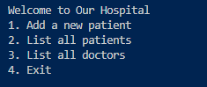

**Page 2:**

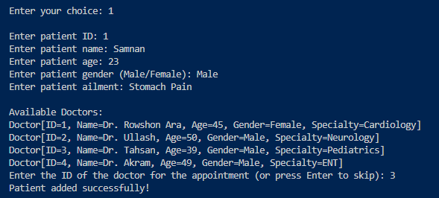

**Page 3:**

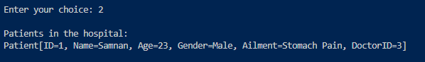

**Page 4:**

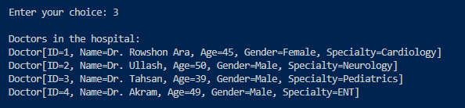

**Page 5:**

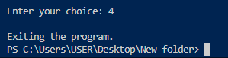

**DFD-0:**

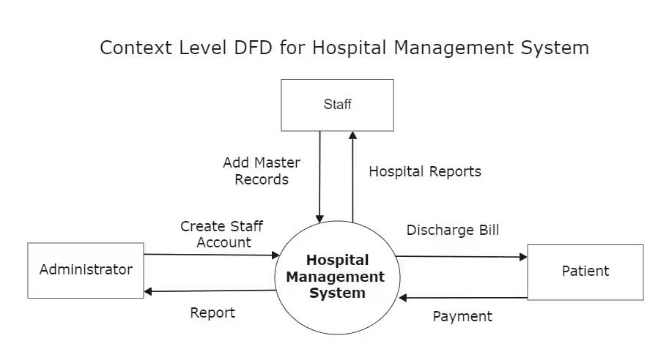

**DFD-1:**

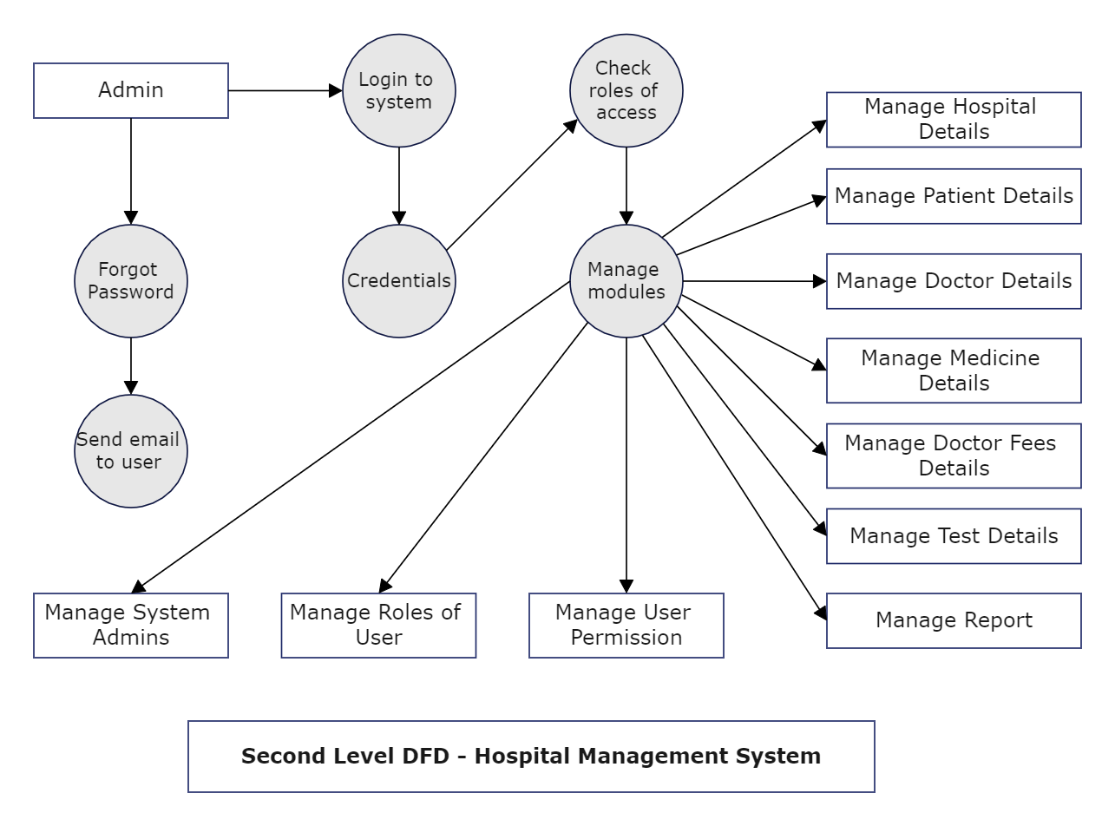

**6. Implementation**

The implementation phase involved:

* Setting up the development environment and defining the class structure.
* Coding the core functionalities such as adding and retrieving patients and doctors.
* Integrating a command-line interface for user interaction.
* Conducting preliminary testing to identify and fix bugs.

**7. Testing**

Testing was conducted to ensure the application functions as intended. This included:

* **Unit Testing:** Each class and method was tested individually to ensure correctness.
* **Integration Testing:** Ensuring different parts of the system work together seamlessly.
* **User Acceptance Testing (UAT):** Gathering feedback from potential users and making necessary adjustments.

**8. Challenges and Solutions**

During the development process, several challenges were encountered, including:

* **Challenge:** Ensuring data integrity and proper linking between patients and doctors.
  + - **Solution:** Implementing careful validation and error handling for user inputs.
* **Challenge:** Providing a user-friendly interface in a command-line environment.
  + - **Solution:** Designing clear prompts and menus to guide the user through the system.

**9. Conclusion**

The Hospital Management System project successfully met its objectives, delivering a functional and user-friendly application for managing hospital operations. The project provided valuable insights into object-oriented programming and command-line interface design.

**10. Future Enhancements**

**Future enhancements for the project may include:**

* Adding new features such as appointment scheduling and billing management.
* Improving the user interface with a graphical user interface (GUI).
* Enhancing security measures to protect sensitive patient data.
* Expanding the application to support larger hospital operations with more complex requirements.